**Chapter-1**

**Introduction**

**1.1** **Mechanical sheet bending**: -

* “Bending implies the deformation of a work piece produced by loads perpendicular to its axis as well as force couple acting in a plane passing through the axis of the bar. Bending is only occurred when load is acting perpendicular to the neutral axes of sheet.”

**1.2** **Introduction: -**

* Now a day in industries especially in automobile and other industries the automatic plate bending machines are widely used. Earlier the bending machines where operated manually. So, the output of machine was very less.
* Because the movement of ram was done manually by rotating the screw. Now the technique of bending operation of the component is changed. Once the plate is loaded the operator should not only use once push button to start the machine. But he has operated two push buttons so that both the hands of the operator are engaged. This arrangement is made in order to avoid injuries to operators.
* The main aim of this project is to have the complete know how of pneumatic devices, sensors etc. by which the manually operated press or any machine can be converted into a semi or fully automatic unit.
* In this project the bending machine is a semi-automatic bending machine, in which the loading and unloading of the component is done manually and the bending of the plate is done automatically.
* This study is about the work of designing a bending machine to bend a pipe. A bending is a process of bending a metal. The metal can be a sheet metal, tubes, square hollow, rod, and iron angle. This type of metal has its own thickness.

The bending machine designer will take into consideration a number of factors including type of metal, type of the roller bender, power driven or manual and the size of the bending machine. Usually, the difference of these types of bending

machine is only on the capacity of the bending machine that can bend a sheet metal or

tube. Today, the bending machine that available in the market is for the sheet metal

and tube bending machine.

* Many machine makers vary their products based on the capacity of the bending machine and power driven or manual. Moreover, most of the machine uses roll bending type. This type of machine has 3 rolls which is 1 roll is fixed and the other 2 are adjustable. The metal pipe needs to put in the roller and then rolls around it until the desire shape is acquired.
* The products that can be produced with this machine are various curves, structural elements, automobile parts etc.

**1.3** **Principle of Sheet bending: -**

* The two most basic and oldest metal working operations are shearing and bending. Shearing is defined as the mechanical cutting of large sheets of metal into smaller pieces of predetermined sizes. A shearing operation that completes an entire perimeter is known as blanking, with the resulting work piece being called a blank.

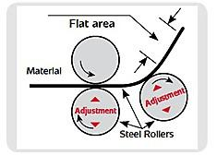

[Fig.1.3.1 Principle of mechanical sheet bending]

**1.4 Types of mechanical sheet bending: -**

* There are many types of mechanical Sheet bending machine which is different with each other according to its working process and the motion of the roller.

**1.4.1 Air type bending: -**

* This bending method forms material by pressing a punch (also called the upper or top die) into the material, forcing it into a bottom V-die, which is mounted on the press. The punch forms the bend so that the distance between the punch and the side wall of the V is greater than the material thickness (T).
* Either a V-shaped or square opening may be used in the bottom die (dies are frequently referred to as tools or tooling). Because it requires less bend force, air bending tends to use smaller tools than other methods.
* Some of the newer bottom tools are adjustable, so, by using a single set of top and bottom tools and varying press-stroke depth, different profiles and products can be produced. Different materials and thicknesses can be bent in varying bend angles, adding the advantage of flexibility to air bending. There are also fewer tool changes, thus, higher productivity.

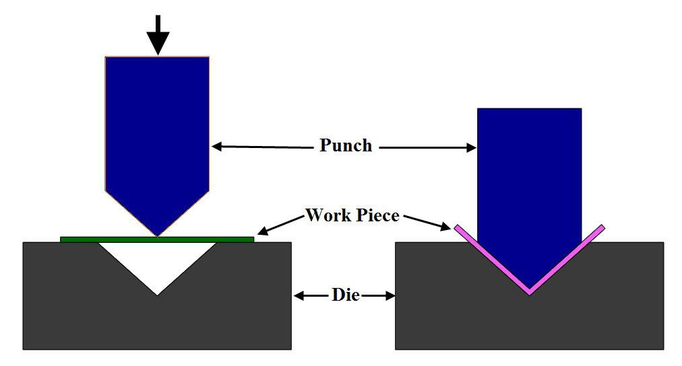

[Fig.1.4.1 Air type bending]

**1.4.2 Bottoming type bending: -**

* In bottoming, the sheet is forced against the V opening in the bottom tool. U-shaped openings cannot be used. Space is left between the sheet and the bottom of the V opening. The optimum width of the V opening is 6 T (T stands for material thickness) for sheets about 3 mm thick, up to about 12 T for 12 mm thick sheets. The bending radius must be at least 0.8 T to 2 T for sheet steel. Larger bend radius requires about the same force as larger radii in air bending; however, smaller radii require greater force—up to five times as much—than air bending.

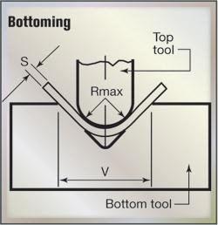

[Fig.1.4.2. Bottoming type bending]

**1.4.3 Three-point type bending: -**

* Three-point bending is a newer process that uses a die with an adjustable-height bottom tool, moved by a servo motor. The height can be set within 0.01 mm. Adjustments between the ram and the upper tool are made using a hydraulic cushion, which accommodates deviations in sheet thickness. Three-point bending can achieve bend angles with 0.25 deg. precision. While three-point bending permits high flexibility and precision, it also entails high costs and there are fewer tools readily available. It is being used mostly in high-value niche markets.

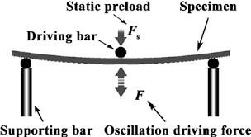

[Fig.1.4.3. Three-point type bending]

**1.5 Advantages: -**

* The machine is only punches information but also analyses them.
* They are used in preparation of wage sheet cost analysis etc.
* They are useful in stock control production control etc.
* These machines are used in libraries, factories police research institutors etc.
* Date is processed at a greater speed.
* There is greater accuracy.
* All function like recording analysing interpretations of dada can be done.
* Very handy machine.
* Available in all modal with many user’s attachment. Its operation is very simple.
* Arithmetical operations can be done.

**1.6 Disadvantages: -**

* The accounting operation must be voluminous enough to warrant the employment of accounting machine.
* Breakdown of power will lead to stoppage of the machine.
* It may lead to the problem of unemployment of persons with special knowledge in accountancy.
* The machine is costly.
* It should be installing in a special place.
* Big companies only can use them to their fullest capacity.
* There is always problem of machine becoming out dated due to rapid change in technology.

**1.7 Application: -**

* To bend sheet having thickness up to 5mm in required angular shape.
* To provide curvature shape to sheet.
* To use for farness, presser vessel etc.
* To use for cylindrical wall for drum. To use for motor mounting.

**Chapter 2**

**2.1 Problem statement**

* Right now, in industry bending operations are performed by manually by applying force by men. Manpower is needed more for this kind of operations and more effort needed for bending operations.
* Metal sheet is bending by applying manual force with the help of bending roller.

**2.2 Problem solution**

* We are reducing men power by implementing the new technique for sheet metal bending and pipe bending. By implementing this system, we can easily bend the metal by rotating the wheel.
* We can make automation also by adding the motor for automating rotation of wheel.

**2.3 Project definition**

* The whole idea behind creating this machine is how to Bend the sheet without more human efforts. So, we thought of creating something which can Bend the sheet in different and required size. This machine is fine example of it.
* There is the handle which is contact with reciprocating mechanism, and reciprocating mechanism is connected to the motor. The motor works on electricity. With the help reciprocating mechanism’s rotation handle will be rotates.
* Due to sheet bending is used for mass production carried out in large amount and it requires less human effort and it consume less time due to vibration required sand grade is carried out by screen frame.
* The benefit of this machine is we can get different shapes of sheet as per our requirement & in very accurate works.
* This machine is use for bend a square pipe and tubes.
* This machine is also use for bend a shaft.

**Chapter: 3**

**3.1 Literature Survey**

* In literature survey, we are finding the different research paper and survey carried on sheet bending machine. we are carried out detailed study of this paper and this data is used as base reference for our project.
* By the study of literature paper, we conclude that the old machine was consuming more human efforts and more time. So, we create some modification in machine and make it more efficient compare to old machine.
* From literature survey we have also find the different application of sheet bending machine which can be useful for industries and fabrication applications.

**3.2 Literature Review**

* Prof. Nilesh Nirwan and Prof. N.M Pooduov, Department of Mechanical Engineering, G.H. Raisoni college of engineering Nagpur has found a PORTABLE ROLLING SHEET BENDING MACHINE is used for reliability, easy convey and good quality purpose. But there are some difficulties like not used for mass production and slow process due to hand operated device.[1]
* Prof. A Pandiyn Department of Mechanical Engineering, Sabetha School of engineering Chennai has found a ZIGZAG SHEET BENDING MACHINE is used for making zigzag profile sheet. It is operated by hydraulic bottle jack. This bending machine is only used for zigzag profile so, not used for other bending operations.[2]
* Prof. Cherniy V.P of Department of Mechanical Engineering, GEC Bhavnagar has found MANUALLY OPERATED SHEETBENDING MACHINE is used in small industries. This machine generally used for low cost purchasing purpose. It has low accuracy of bending and force is not uniformly distributed over a whole length of pipe so, this bending machine is not preferable.[3]
* Prof. Modak S.P Pervez of Department of Mechanical Engineering, Anjuman college of engineering and Technology, Chennai Nagpur, has found a BICYCLE INTEGRATED SHEET DESIGN BENDING MACHINE. It is unlike other electric motor operating pipe bending machine. It is used for ECONOMIC & ACCURATE DIMENSION. It will help to maintain environment green. Here is one Disadvantage is process taking more time.[4]

* Prof. Khurmi R.S. And Gupta J.K. Of Department of Mechanical Engineering, of Federal University Owerri Nigeria has found MOTORIZED SHEET BENDING MACHINE WHICH IS OPERATED by 2HP MOTOR. This machine can run in both upward and downward direction. Here worm and wheel gear mechanism are used. Mandrel used for less thickness sheets.[5]
* [P. S. Thakare, P. G. Mehar, Dr. A, V, Vanalkar, Dr. C. C. Handa, “PRODUCTIVITY ANALYSIS OF MANUALLY OPERATED AND POWER OPERATED SHEET BENDING MACHINE: A Comparative Study”, International Journal of Engineering Research and Applications.](https://www.ijert.org/)[6]
* The machine proposed is designed to bend a sheet into a cylindrical hollow body. It may, for instance, be a triple-roller machine in which the roller section designed to grip the sheet is delimited by two pillars. [https://patents.google.com/patent/WO1997027957A1/en]. [7]
* Bend rods. bars. wires and similar materials into a variety of forms suitable for structural purposes, such as reinforcements for concrete structures Machines of this kind previously used were hand operated and the degree of bending was usually gagedonly bftheeye with perhaps the aid ofa chalk mark on the machine. As a resultthe different pieces, supposedly of the same were not bent to the same angle thus intro ducing inaccuracies in the set-up reinforcing structure. Only a limited number of bends could be made. the accuracy of which largely depended on the skill of the operator in stopping the machine when the bar wjas bent. [https://patents.google.com/patent/US1465733A/en]. [8]
* The present invention relates to a sheet-metal bending machine. It comprises a fixed support structure. [https://patents.google.com/patent/EP0490828A1/en].[9]
* Our invention relates to a sheet-metal-bending machine; and it has for its object to provide a very simple and inexpensive bending machine adapted to bend at an angle any kind of sheet metal at any temperature without cutting or otherwise injuring the metal. [https://patents.google.com/patent/US671312]. [10]
* This invention relates to a bending machine of a simple type adapted to bend cold or hot material, the machine being of a type adapted to be attached to a post or bench in a shop and being operable by hand. Such bending machines are of great utility in small blacksmiths shops, garages, farm shops, spring factories, etc.[https://patents.google.com/patent/US1523594]. [11]

**Chapter: 4**

**4.1 Market survey analysis:**

**Market survey report on “Sheet bending machine”**

**AIM**: - To reduce the efforts and time of the worker and employees for bending sheet with the help of sheet bending machine. This is used in industry and fabrication workshops.

Objective: -

* The main objective of this machine is bending the sheet with the help of manually or electric sheet bending machine.
* It reduces Human's effort and also required low skilled worker to operate this machine.
* We were making manually with electric power operated sheet bending machine.
* We were used 3 or 4 rollers, electric motor with capacity 1.16 HP, 230-volt, 2800 rpm, 50 W and iron channel, bearings for holding rollers in this machine for bending operation.
* This machine has low costing compare to other product and higher quality output with less effort.

Methodology

* To do the market survey on our project we used QUANTITATIVE method in which we asked following questions.

Our Questions are as follow: -

**Q.1: - Are you satisfied with your current product?**

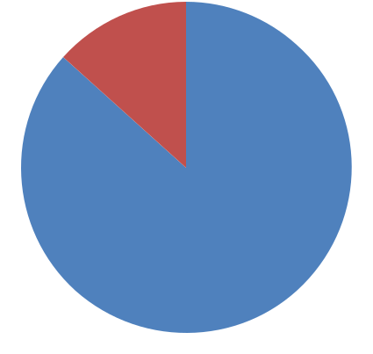

13%

 YES

 NO

87%

[Fig.4.1 Current product]

**Q.2: - Which type of bending machine are you used?**

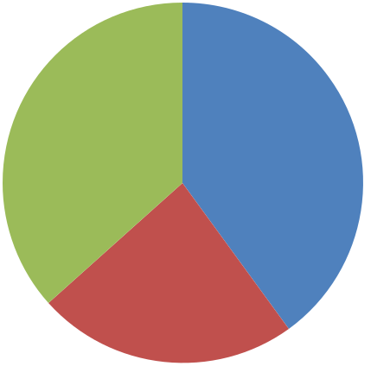

|  |  |
| --- | --- |
| 37% | MANUALLY |
| 40% |
|  |
|  | ELECRICALLY |
|  | MANUALLY WITH |
|  | ELECRICALLY |
|  | 23% |



[Fig.4.2 Existing product]

**Q.3: - How much quality of your existing product?**

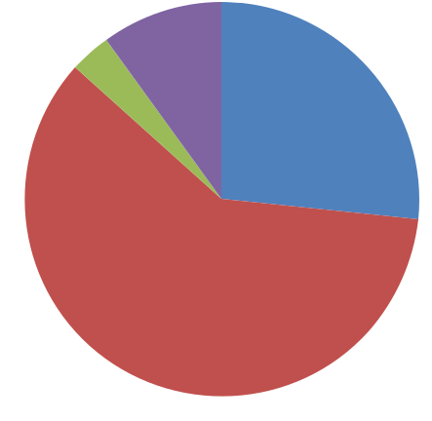

|  |  |  |
| --- | --- | --- |
|  | 10% |  |
| 3% | 27% | VERY GOOD |
|  |
|  |  |



 GOOD

 VERY BED

 BED

60%

[Fig.4.3 Quality of existing product]

**Q.4: What is the time period of maintenance of existing machine?**



23% 23%

|  |  |
| --- | --- |
|  | 0 TO 2 MONTH |
|  | 2 TO 4 MONTH |
|  | 4 TO 6 MONTH |
| 20% | 6 TO 8 MONTH |
|  |



34%

[Fig.4.4 Time period of maintenance existing product]

**Q.5: - How much time required to maintenance of existing machine?**



30% 27%

 0 TO 1 HOUR

 1 TO 2 HOURS

 2 TO 3 HOURS

 3 TO 4 HOURS

20%

23%

[Fig.4.5 Time required in maintenance]

**Q.6: - If our product were available today, how likely would you be buying the product?**



10%

37% 13%  EXTREMELY LIKELY

 VERY LIKELY

 SOMEWHAT LIKELY

 NOT AT ALL

40%

[Fig.4.6 Buy our product]

**Q.7:** **How much cost of your existing product?**

* Existing product cost is 75,000 to 1, 50,000 Rupees.

**Q.8:** **How much capacity of your existing machine?**

* Existing product capacity is 0.5 mm to 6 mm thickness.

**Q.9:** **What is the size and weight of the existing machine?**

* Average weight of existing machine is 180 to 600 kg.
* Average size of existing machine is 6’x 8’x 9’.

**Q.10:** **How much cost consume in maintenance of existing product?**

* Cost consume in maintenance of existing product is RS. 2000 to 15000.

**Q.11: Which difficulties are generating when using the current machine?**

* Main problem is that its take more time and power consumption.

**Q.12: What is the new innovative suggestion in existing machine?**

* If possible then it should be work multiple operations, low cost and high efficiency.

**Q.13: If the product were available then how much you can pay for our product?**

* They can pay Rs. 30,000 to Rs. 80,000.

**MARKET SURVEY CONCLUSION: -**

* From the Market survey we conclude that, the budget of our project is approximately 25000 Rs.
* Our product having low cost and less maintenance compare to other product so that people are interested somewhat likely to buy our product.
* We remember all feedback which gets during the market survey and we try our best to fulfil all feedback in product as soon as possible.

**4.2 Feasibility report**

CONTENT:

General information

* Feasibility:
  1. Technical feasibility
  2. Marketing feasibility
  3. Commercial feasibility
  4. Financial feasibility
* Project plan details:
  + 1. Product related details
    2. Machines, equipment’s, technology etc.
    3. Cost of project and means of financing the project.
    4. Demand and market condition.
    5. Overall evaluation

General information:

Name of group leader: Kavan (218SBEME30509)

Email Id: [kavanratna@gmail.com](mailto:kavanratna@gmail.com)

Names of group members:

|  |  |  |  |
| --- | --- | --- | --- |
| 1. Aftab | (218SBEME30514) | 5.Krunal | (218SBEME30510) |
| 2. Prashant | (218SBEME30516) |
| 3. Kavan | (218SBEME30509) |
| 4. Hitesh | (218SBEME30507) |

Name of guide: Mr. Chandra Mauli

Name of organization: Ldrp-itr, Gandhinagar

Technical feasibility:

* In our project we use I-section channel, 3 rollers, electric motor with capacity of 1.16 HP, 230 V, 2800 rpm and 50 W. One roller’s length is 36cm and other two roller’s length is 30cm used for bend the sheet. Sheet bending machine made of iron metal channel and also use 4 holding bearings, 2 flange bearings for holding rollers etc. The capacity of bending machine is 5 mm thick sheet. It is easily available in market. Electric motor issues in mechanism and the structure of machine which can be easily assemble in workshop. Hence, the assembly of this parts and working mechanism seems to be feasible. We are able to overcome to all the challenges occurring in our product idea and innovative concept.

Marketing feasibility:

* The sheet bending machines are use in small industry and workshop. This machine will be use by sheet bend job workers and fabrication workshops. Its main objective is to reduce efforts and time for bending the sheet in industry and work shop. It assembly and construction is simple, less expensive and with low maintenance cost compare to existing product. This conclusion has been made by performing market survey.

Commercial feasibility:

* As a product, it has less expensive cost of mechanism, simple construction and it requires less maintenance compare to existing product. So, this product is efficient than existing products and with less initial cost.

Financial feasibility:

* The capital investment is done by the group members of the project.

Product related details:

* Sheet bending machine
* The development of prototype is done with the help of a design industry.

Cost of project and means of financing the project:

* The unit (Ldrp-itr) is funding and collaborates with the design industry to design and develop the Sheet bending machine.
* Following is the cost estimation of the Sheet bending machine.

Demand and market condition:

* Nature of market:

According to the market survey, most of the Sheet bending machine users are interested into purchase the machine. Either they are not introduced with the other manufacturing companies or they are not completely satisfied with the product.

* The positive response is acquired and it is commercial feasible because on the basis of market survey at list breakeven point can be achieve.

Overall evaluation:

* Following are the critical factors which affecting the success.
* A human effort is less.
* Quality output.
* It is feasible.

Approx. investment of product/project=35,000/-

Labor cost=3500/-

Overheads=2250/-

|  |  |
| --- | --- |
| Prime Cost | = Material cost + Labor cost |
|  | = 18400 + 3500 |
|  | = 21900/- |
| Total Cost | = Prime cost + Overheads (10%) |
|  | = 21900 + 2190 |
|  | = 24090/- |
| Selling Price | = 30000/- |
| Profit | = Selling price – Total cost |
|  | = 30000 – 24090 |
|  | = 5910/- |

Conclusion:

* From the Market survey and Feasibility report we were concluded that as the positive response is gained, this project can be established as a product in the market and from that day onwards we start research and development of the optimum design which is described in the next chapter.

**Chapter: 5**

**5.1 Project design**

Sheet bending machine

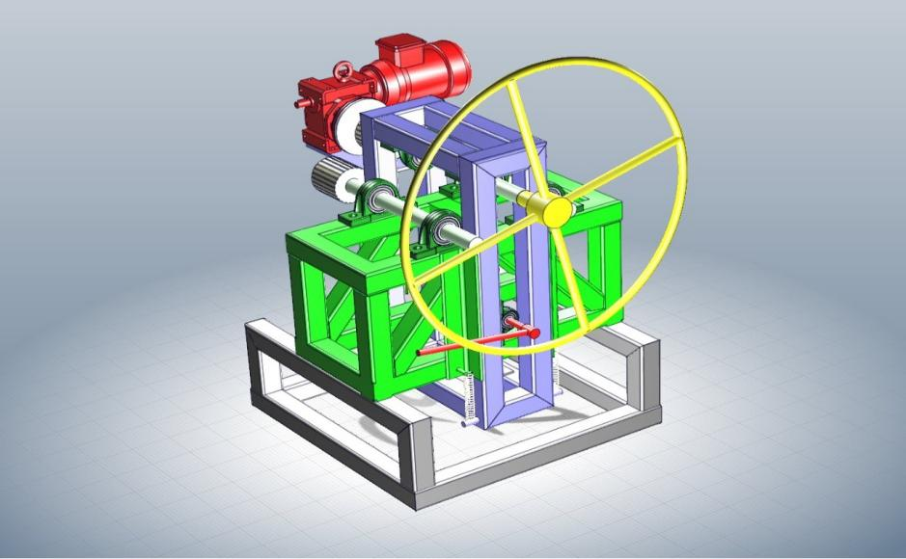

[Fig.5.1.1 3D isometric view of sheet bending machine]

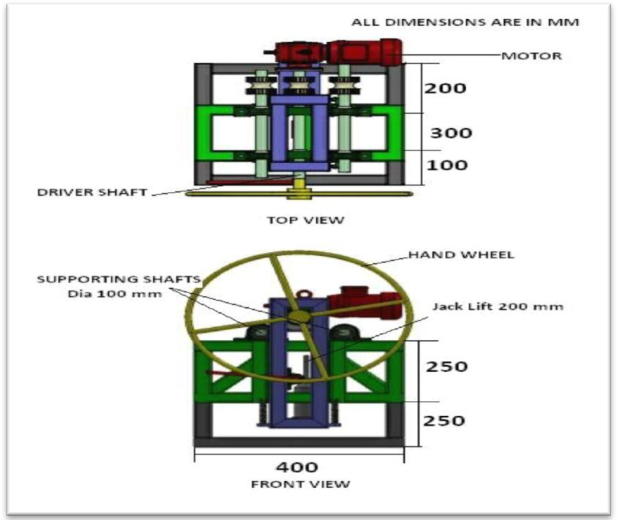

[Fig.5.1.2 Front view of sheet bending machine]

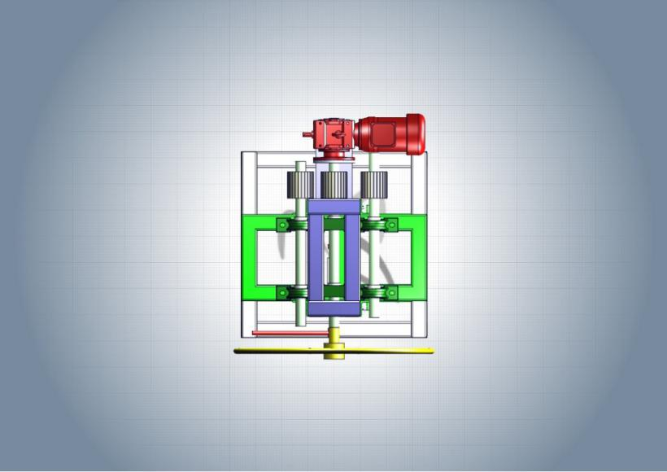

[Fig.5.1.3 Top view of sheet bending machine]

**5.2 Hardware**

* Spring

Spring is used for inversion of control container between container and platform.

Material: - Mild Steel

Size: -40mmX60mm

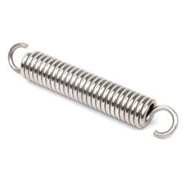

[Fig.5.2.1 Spring]

* **Hydraulic jack**

It is use for leaf ting frame and other parts.

Material: -Cast Iron

Size: - 3.5kg

Capacity: - 1 ton

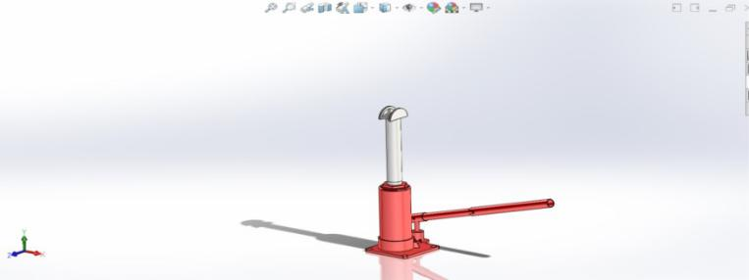

[Fig.5.2.2 Hydraulic jack]

* **Square pipe**

Square pipe is used to make rectangular structure.

Material: - Mild steel

Size: -30mmX30mmX2000mm

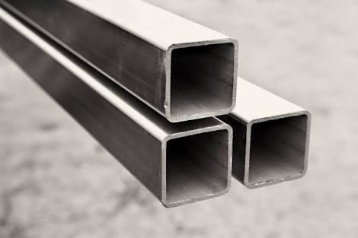

[Fig.5.2.3 Square bars]

* **Nut & bolts**

Nuts are almost always used in conjunction with a mating bolt to fasten two or more parts together.

Material: - Mild steel, alloy steel, Carbon steel

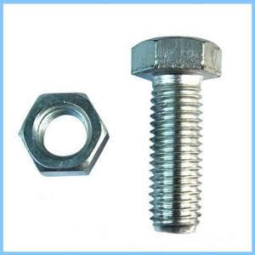

[Fig.5.2.4 Nut & bolts]

* **Gear**

It is use for transmit power

Which are use bevel gear

Material: - cast iron, steel

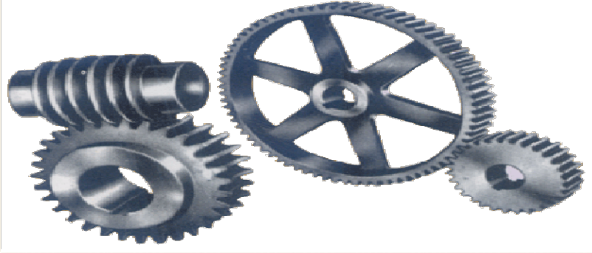

[Fig.5.2.5 Gear]

* **Flange bearing**

We are use flange bearing in project as a roller’s supporter.

Material: - Cast iron.

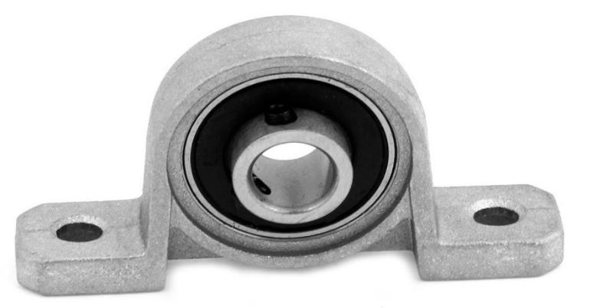

[Fig.5.2.6 Flange bearing]

* **Motor**

Motor is used to make motion in handle by taking electricity.

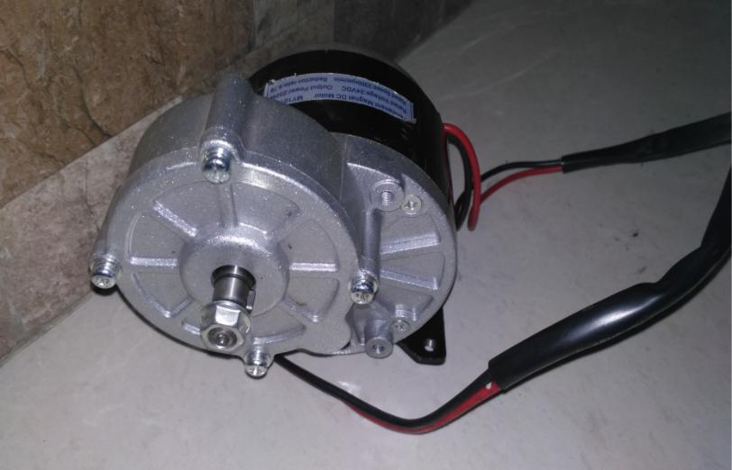

[Fig.5.2.7 Motor]

**Specification of DC motor**

Permanent magnet DC motor



|  |  |
| --- | --- |
| Rated voltage | 230 VDC |
| Rated speed | 2800rpm/min |
| Output power | 250w |
| Rotation | Clock wise, anti-clock wise |
| Actual speed | 337rpm/min |

[Table.5.2.1 Specification of DC motor]

**Chapter: 6**

**6.1 Costing and specification**

Estimated cost:

|  |  |  |
| --- | --- | --- |
| Parts | No. of Product | Rupees |
| Angle | 1.8 meter | 1200 |
| Spring | 4 | 700 |
| Rollers | 3 | 750 |
| Square pipe | 4 meters | 3700 |
| Nut & bolts | 14 | 300 |
| Bearing(pedestal) | 6 | 1500 |
| Motor | 1 | 3950 |
| 3 phase switches | 1 | 430 |
| Handel | 1 | 500 |
| Hydraulic jack | 1 | 4850 |
| Welding cost | - | 1920 |
| Paint | - | 400 |
| Transportation cost | - | 1800 |
| Total |  | 22,000 |

[Table.6.1.1 Estimation Cost]

**6.2 List of components required**



|  |  |  |  |
| --- | --- | --- | --- |
| Sr. no | Component |  | No. |
|  |  |  |  |
| 1 | Motor | 1 | |
|  |  |  |  |
| 2 | Adopter | 1 | |
|  |  |  |  |
| 3 | Flange Bering | 8 | |
|  |  |  |  |
| 4 | Roller | 3 | |
|  |  |  |  |
| 5 | Mild steel square bar | - | |
|  |  |  |  |

[Table 6.2.1 List of components]

Chapter-7

7.1 Outline to be carried out for sem-8th

* We are making of the machine planning and design.
* list out the all parts and raw material and collect and by the parts or raw material.
* The making of all parts assembly as per design.
* The fabrication the all parts and making of prototype of machine.
* Inspection of machine.
* The final machine finishing and painting process.
* The all overall machine costing and final price decide.

Flow chart

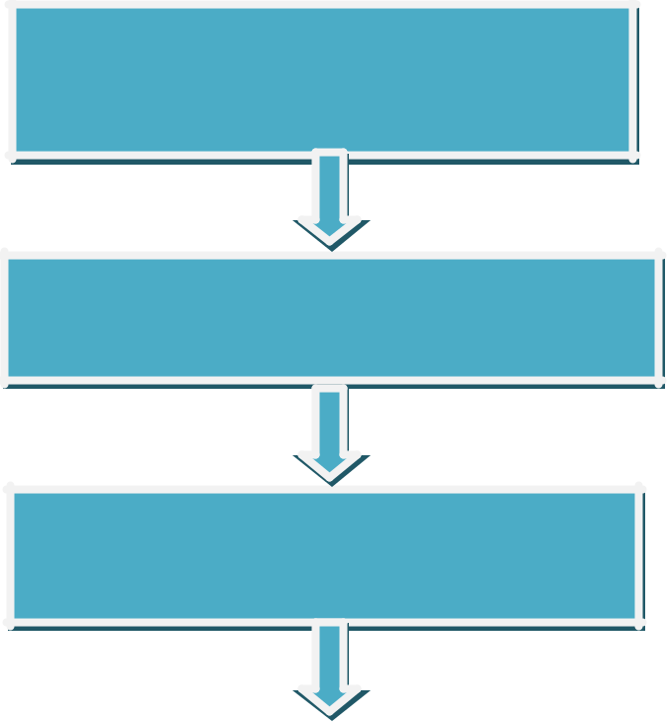

We are papering and the making of the

machine planning and design.

The all overall machine casting and final price

decide.

The making of all parts assembly as per

design.

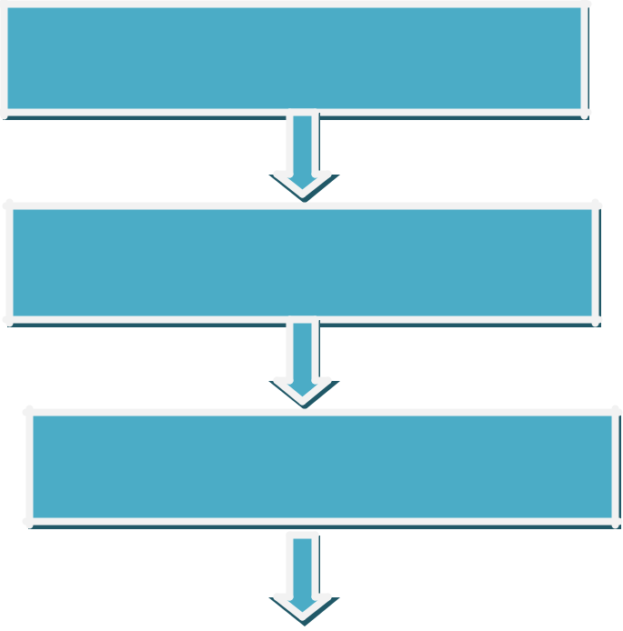

The fabrication the all parts and making

of prototype of machine.

The making of the design with all parts

dimension.

Inspection the his strength, toughness and

structure balancing.



The final machine finishing and paint process.

**Chapter: 8**

**8.1 SWOT analysis:**

* The following SWOT analysis captures the key strengths and weakness within the project and describes the opportunities and threats facing double side sheet bending machine.

**Strength**

* This machine consumes less time.
* This machine requires less human effort.
* This machine gives high productivity and high accuracy.
* It has simple construction and easy to operate.
* It is easy to maintain it.
* All the operations are performed by only one motor.
* The machine output is 2x, because of double sided screen frame.

**Weakness**

* The size of the machine is small.
* This machine does not bend large size of sheet.

**Opportunities**

* A large percentage of construction and agricultural market is unaware of SHEET BENDING MACHINE.
* This machine is used in fabrication shop, where more accurate work is required. This machine is used where bending operation is done.

**Threats**

* Machine can occur problem during rainy season.
* This machine could screen sand when it is normal but can’t screen proper wet sand.

## Conclusion:

* So, from this work we conclude that our sheet bending machine will overcome the problems that are present related to bending sheet.

## It’s simple and compact design.

**Chapter: 9**

**BIBLIOGRAOHY/REFERNACE**

**BOOKS: AUTHOR**

|  |  |  |  |  |  |  |
| --- | --- | --- | --- | --- | --- | --- |
|  | Books | | | | | Author |
| Manufacturing engineering and Technology | | | | | | Serope Kalpak jian |
| Metal Forming Technology and Process Modeling | | | | | | Uday S. Dixit |
| Fluid Mechanics and Hydraulic Machines | | | | | | R.K.Rajput |
| Machine Design | | | | | | Dr. P. C. Sharma |
| **Websites: -** | | | | | |  |
| * www.google.com | | | | | |  |
|  |  |  |  |  |  |  |
| * www.classle .net/projects/node/255 | | | | | |  |
|  |  | |  |  |  |  |
| * www.technicaljournalsonline.com/jers | | | | | |  |
|  |  | |  | |  |  |
| * www.wikipedia.com | | | | | |  |
|  |  |  |  |  |  |  |

**Research paper**

1. Prof. N.M Poodunov “calculation of setup variables using finite difference method”, Russian aeronautics Vol.54, Issue.1 pp 89-94. [April 2011] (www.tjritcc.org).
2. Prof. A Pandiyn “computational method of spring back in bending of sheet having busing effect, steel research int”. Vol.5, Issue 8, pp 757-760. [2010]. (WWW.UPCOMMONS.UPC.EDU.COM).
3. Prof. Cherniy V.P. “effect of curved bar properties on bending of curved sheet. journal of applied machaincs”. Vol.68, pp 650-655. [2001]. (www.mantechpulication.com).
4. Prof. Moduk S.P. “hypothesis for the evtrusion of lime flash sand brick using a manually driven brick making machine building research and information”. Vol.22, Issue 1 , pp 42-54. [2013]. (www.iosrjournal.org).
5. Prof. Khurmi.R.S. And Gupta J.K. “workshop technology (manufacturing process). Vol.4, Issue. 4, pp 341-345. [2004].(www.iet.jounrals.org).

6. P. S. Thakare, P. G. Mehar, Dr. A, V, “Productivity Analysis of Manually Operated and Power Operated Sheet Bending Machine: A Comparative Study”, International Journal of Engineering Research and Applications, Vol. 2, Issue 2, Mar-Apr 2012, pp.111-114.([www.ljert.org](http://www.ljert.org/)).

7. Jörg HAEUSLER (inventor) a “triple-roller machine”, [https://patents.google.com/patent/WO1997027957A1/en].

8. Julius H Holmgreen(inventor) “structures bending Machines” Serial No. 315,154 [August 4,1919], [https://patents.google.com/patent/US1465733A/en].

9. Luigi Patuzzi(inventor) “sheet-metal bending machine” [https://patents.google.com/patent/EP0490828A1/en].

10. Gaston Delachartre(inventor) “sheet-metal bending machine” [https://patents.google.com/patent/US671312].

11. Hossfeld Albert(inventor) “bending machine” [July 11, 1923] [https://patents.google.com/patent/US1523594].